Reiview Quetstion

Q14 - 1.

The five necessary components of DBMS are hardware, software, data, users, and procedures.

Q14 - 2.

The three models of databases are hierarchical, network, and relational. The relational model is the one used today.

Q14 - 3.

In the relational model, a relation is a set of data organized in a two-dimensional table. The relations are related together.

Q14 - 4.

An attribute is a column in a relation: A tuple is a row in a relation

Q14 - 5.

Some unary operations are insert, delete, update, select, and project.

Q14 - 6.

Some binary operations are join, union, intersection and difference.

Q14 - 7.

The Structured Query Language (SQL) is a language standardized by the American National Standards Institute (ANSI) and the International Organization for Standardization (ISO) for use on relational databases. Extensive Markup Language (XML) is a markup language designed to add markup information to text document, but it also has found its application

Problems

P14 - 1

|  |  |  |
| --- | --- | --- |
| A1 | A2 | A3 |
| 2 | 16 | 102 |
| 3 | 16 | 103 |

P14 - 2

|  |  |
| --- | --- |
| A1 | A2 |
| 2 | 16 |
| 3 | 16 |

P14 - 3

|  |
| --- |
| A3 |
| 100 |
| 102 |
| 103 |
| 104 |

P14 - 4

|  |
| --- |
| B1 |
| 24 |
| 29 |

P14 - 5

|  |  |  |
| --- | --- | --- |
| C1 | C2 | C3 |
| 32 | 401 | 1025 |
| 33 | 405 | 1065 |
| 37 | 401 | 1006 |

P14 - 6

select No, Unit

from COURSES

P14 - 7

select ID, Name

from STUDENTS

P14 - 8

select Name

from PROFESSORS

P14 - 9

select Name

from DEPARTMENTS

P14 - 10

select Courses

from STUDENTS

where ID = 2010

P14 - 11

select Courses

from PROFESSORS

where Name = ‘Blake’

P14 - 12

select *

from COURSE

where Unit =3

P14 - 13

select Name

from STUDENTS

where Courses = ’CIS015’

P14 - 14

select No

from DEPARTMENTS

where Name = ‘Computer Science’

P14 - 15

|  |  |  |  |
| --- | --- | --- | --- |
| A | B | C | D |
| 1 | 70 | 65 | 14 |
| 2 | 25 | 24 | 12 |
| 2 | 25 | 24 | 18 |
| 2 | 32 | 24 | 12 |
| 2 | 32 | 24 | 18 |
| 2 | 71 | 24 | 12 |
| 2 | 71 | 24 | 18 |
| 3 | 32 | 6 | 18 |
| 3 | 32 | 11 | 18 |

P14 - 16

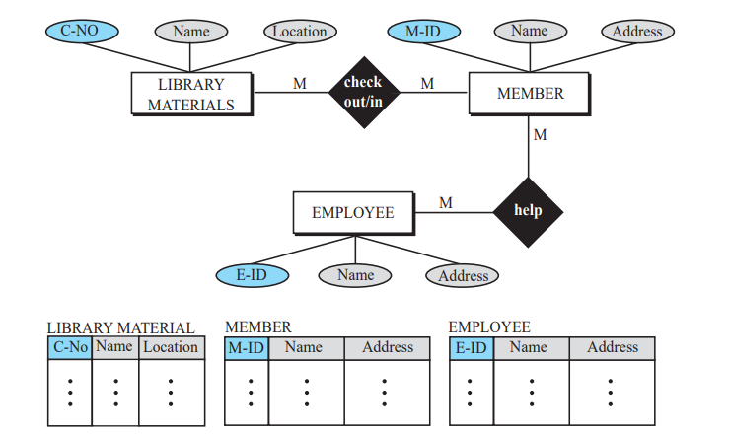

P14 - 17

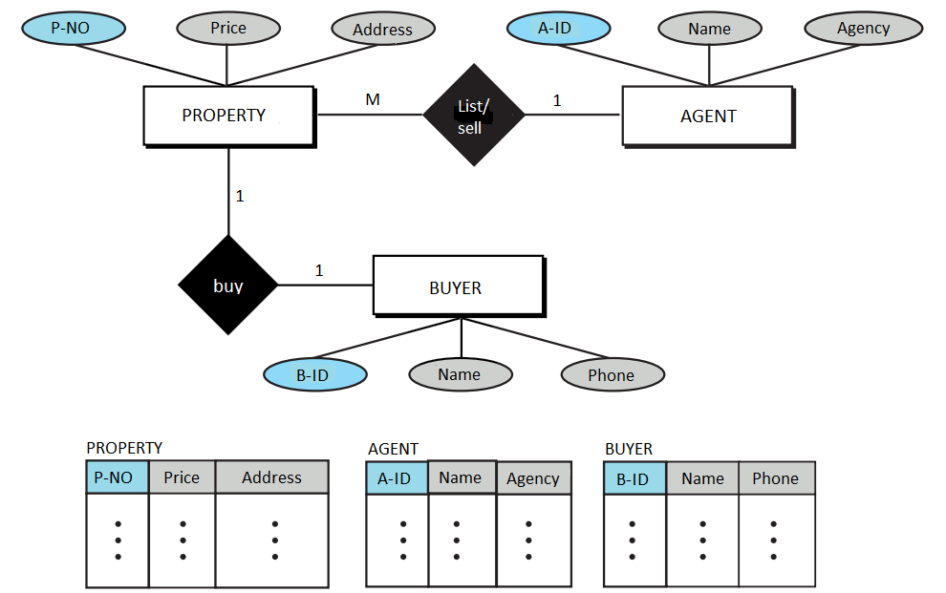

P14 - 18

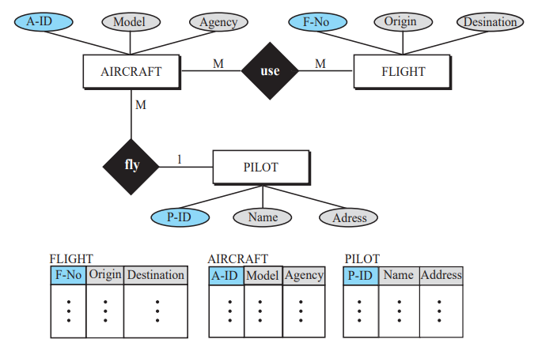

P14 - 19

The third normal form (3NF) is based on the concept of a transitive dependency. A functional dependency X → Y in a relation R is a transitive dependency if there is a set of attributes Z that is not a subset of any key of R, and both X → Z and Z → Y hold.

P14 - 20

Boyce-Codd normal form (BCNF) is the revised 3NF that covers a special case not covered by 3NF. For more information see the references at the end of the chapter of the text.